Logon Status

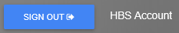

The Logon Status is located to the immediate right of the Sign Out button. It displays the name of the user currently logged in (rather than the user name from the Login Page). For example, if John Smith logs into the program with the user name "Jsmith," the Logon Status will be “John Smith."

